Twitter Analytics
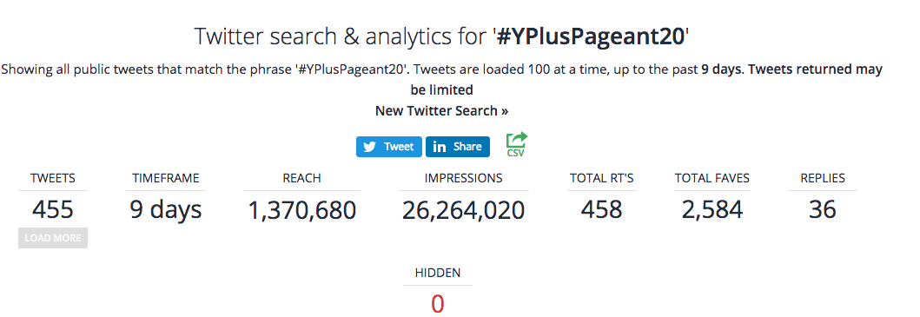
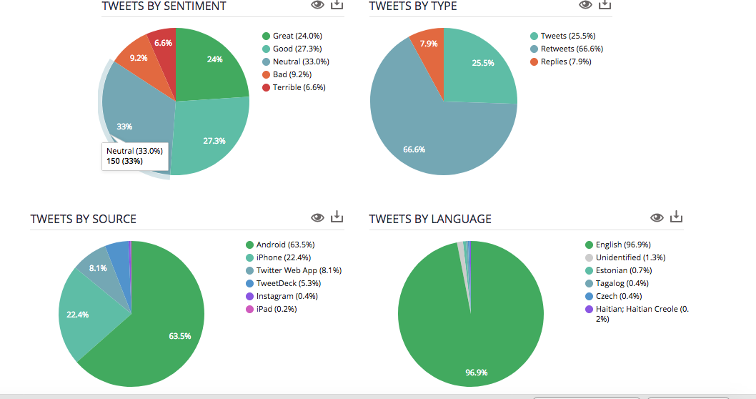
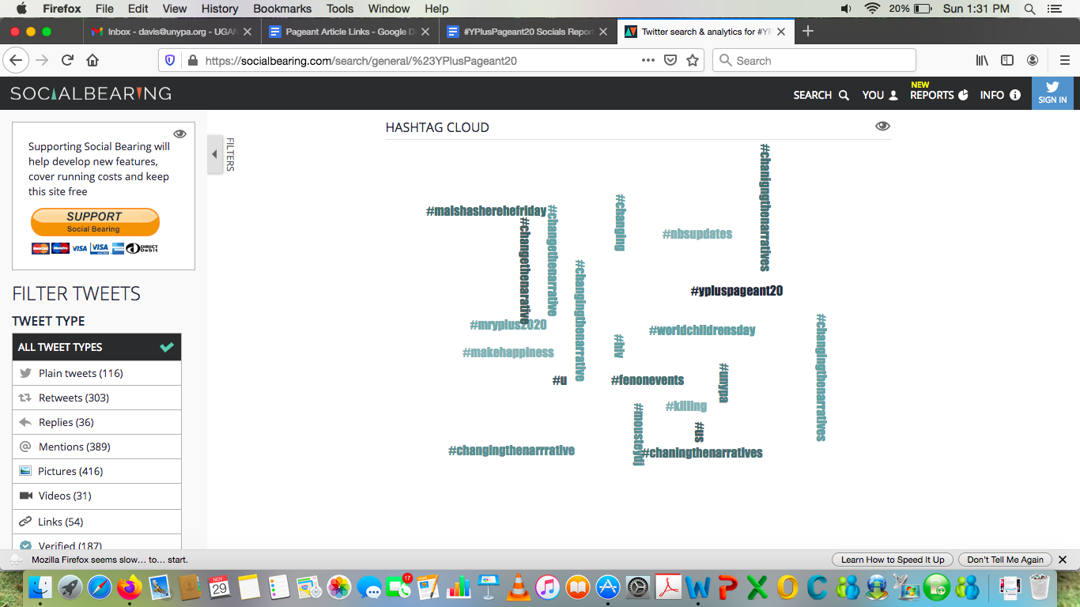
Sample Posts
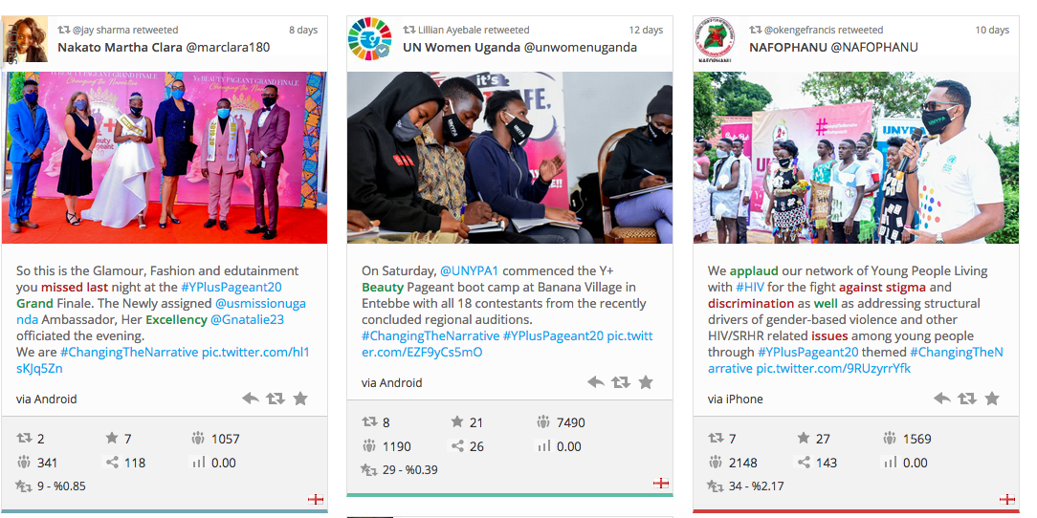
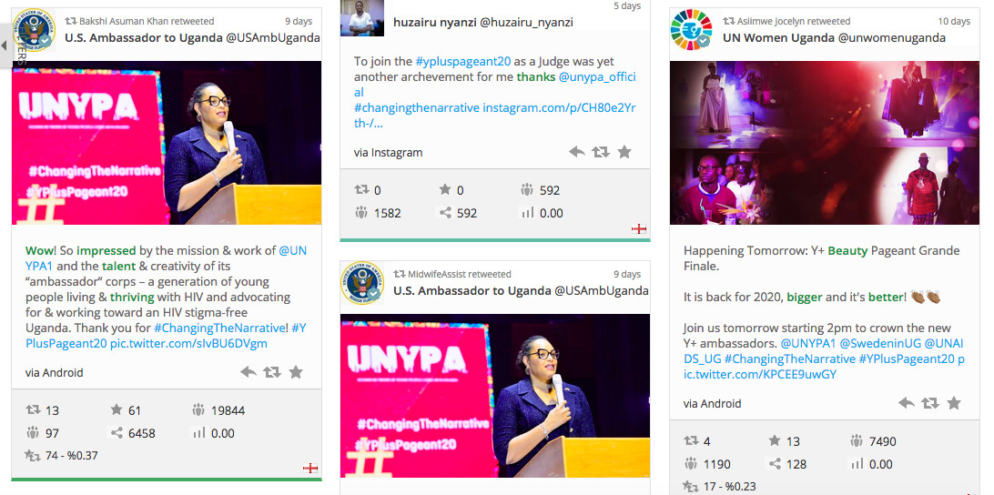
Overview
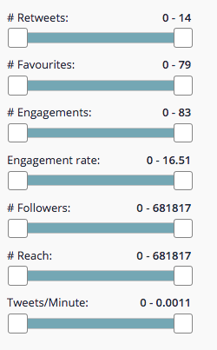

Useful Links For Media

- UNYPA Unveils New HIV/AIDS Stigma And Discrimination Ambassadors https://thetowerpost.com/2020/11/23/unypa-unveils-new-hiv-aids-stigma-and-discrimination-ambassadors/

Northern region takes the Y+ Beauty Pageant grand finale https://www.newvision.co.ug/news/1533322/northern-region-takes-beauty-pageant-grand-finale
- https://theugandan.com/2020/11/aol-gladys-and-oscar-otim-win-the-crown-as-top-ambassadors-against-hiv-aids-stigma-and-discrimination-2/

Who will be crowned the next Mr Y+/Miss Y+? https://www.newvision.co.ug/news/1530769/crowned-miss
- Naturinda wins HIV Beauty Pageant For Western Uganda https://chimpreports.com/naturinda-wins-hiv-beauty-pageant-for-western-uganda/

UNYPA To Unveil Mini Condom Campaign At Launch Of Y+ Beauty Pageant This Friday https://thetowerpost.com/2020/09/24/unypa-set-to-launch-a-virtual-mini-condom-campaign-together-with-the-y-beauty-pageant-this-friday/
- UNYPA launches condom use campaign to reduce STDs incidence, and unwanted pregnancies https://chimpreports.com/unypa-launches-condom-use-campaign-to-reduce-stds-incidence-unwanted-pregnancies/

The Y+ Beauty Pageant 2020 launched https://www.newvision.co.ug/news/1528032/beauty-pageant-2020-launched

Health workers to drive youth to suicide in Northern Uganda using stigma https://www.independent.co.ug/health-workers-to-drive-youth-to-suicide-in-northern-uganda-using-stigma/
- HIV is not a death sentence - Kwania LC5 Boss https://chimpreports.com/hiv-is-not-a-death-sentence-kwania-lc5-boss/
- Who Will Wear The Y+ Beauty Pageant Crown? https://campusbee.ug/news/who-will-wear-the-y-beauty-pageant-crown/

UNYPA UNVEILS THE WESTERN AMBASSADORS OF THE Y+ BEAUTY PAGEANT IN KABALE https://theugandan.com/2020/11/unypa-unveils-the-western-ambassadors-of-the-y-beauty-pageant-in-kabale/

CENTRAL REGION GETS NEW AMBASSADORS TO SPEAR HEAD FIGHT AGAINST HIV STIGMA AND DISCRIMINATION https://theugandan.com/2020/10/central-region-gets-new-ambassadors-to-spear-head-fight-against-hiv-stigma-and-discrimination/
- UNYPA to Launch a mini condom campaign and the Y+ Beauty Pageant https://ugmirror.com/index.php/2020/09/24/unypa-to-launch-a-mini-condom-campaign-and-the-y-beauty-pageant/

UNYPA Set to Launch Y+ Beauty Pageant 2020 http://thisisuganda.org/unypa-set-to-launch-y-beauty-pageant-2020/

Y+ Beauty Pageant: This Pageant Aims at Fighting Stigma And Discrimination of Young People Living With HIV http://thisisuganda.org/y-beauty-pageant-this-pageant-aims-at-fighting-stigma-and-discrimination-of-young-people-living-with-hiv/
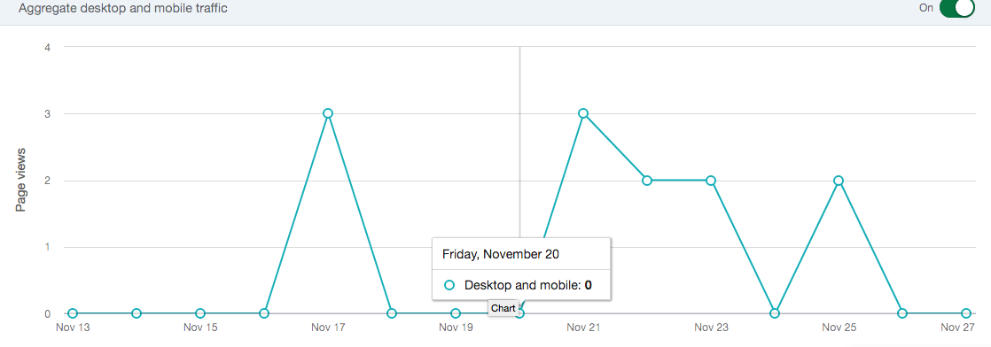
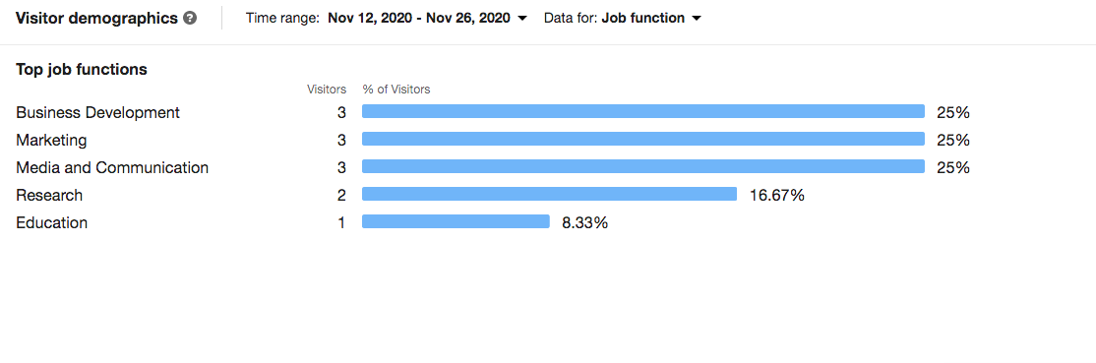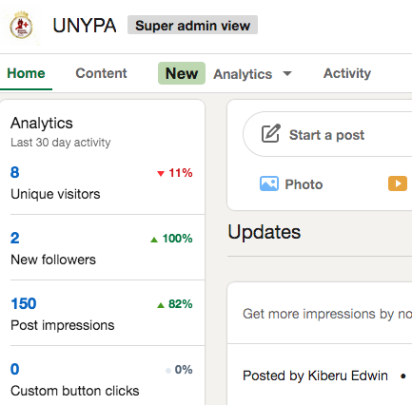
Facebook Analytics
Page URL - https://web.facebook.com/YplusBeautyPageant
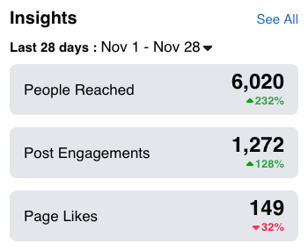
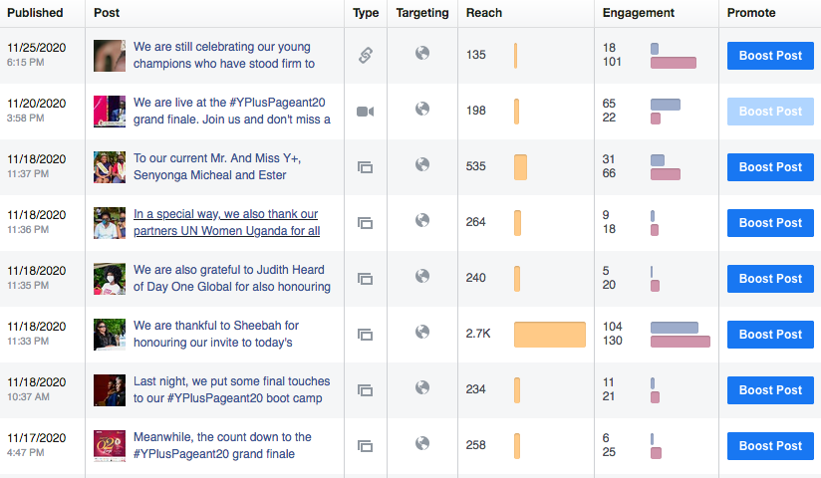
More Post Data -
https://web.facebook.com/YplusBeautyPageant/insights/?section=navOverview or https://docs.google.com/spreadsheets/d/10nvzmedsViFEiSrGiXpVGUImgABy5Gbnvz3glA05n2c/edit?usp=sharing

